Catering Menus

Our catering menus have been designed to provide you with a wide variety of options. Our skilled staff can also create customized menus upon request. Buffet menus are priced for 1 hour of service time. Refreshment break pricing reflects 1.5 hours of service time.
Outside catering is not permitted in our banquet rooms. All food and beverage items must be purchased through the hotel.
Please remember to add 6% sales tax and 20% service charge to all menu pricing. Buffet menus require a guarantee of 25 persons, or an additional $2 per person will be added to the menu price.

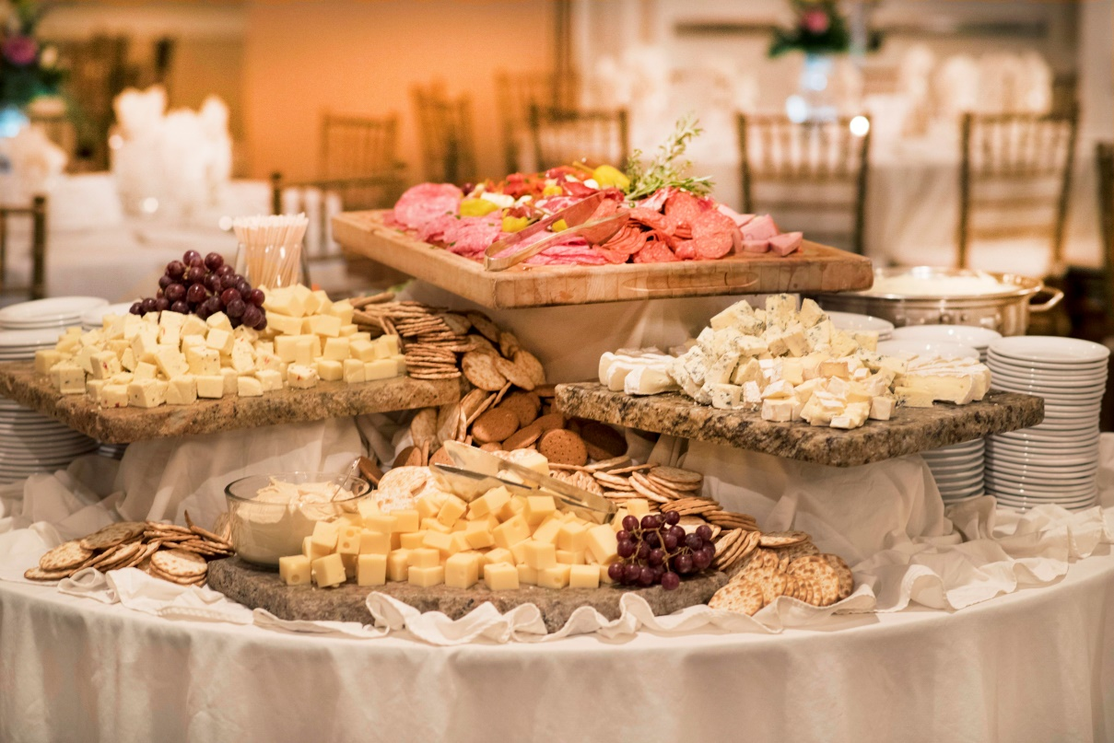
Breakfast
Rise and Shine Buffet
Fluffy scrambled eggs
Turkey sausage links
Crispy Bacon
Home fried potatoes
Freshly baked muffins
Assorted bread for toasting
Butter, Assorted Preserves
Orange, Apple, and Cranberry Juices,
Coffee, Tea, Decaffeinated Coffee
$12 per person

Healthy Morning Buffet
Sliced fresh seasonal fruit
Assorted yogurt
Granola
Oatmeal with toppings
Muffins
Assorted Bagels
Butter, Assorted Preserves
Orange, Apple, and Cranberry juices
Coffee, Tea, Decaffeinated coffee
$12 per person

Classic Breakfast Buffet
Fresh sliced fruit
Fluffy scrambled eggs
Crispy bacon
Turkey sausage links
French Toast with maple syrup
Home Fries
Chef’s selection of assorted breakfast pastries
Orange, Apple and Cranberry Juices
Coffee, Tea, Decaffeinated coffee
$14 per person

Additions
Egg White Frittata
+$2 per person
Mushroom and Spinach Quiche
+2.25 per person
Chef Attended Made-To-Order Omelet Station
+$4 per person plus $50 chef fee

Refreshment Breaks
AM Selections

The Eye Opener
Freshly Brewed Coffee
Assorted Teas
Decaffeinated Coffee
Chef’s Choice breakfast pastry
$4.75 per person

Continental
Freshly Brewed Coffee
Assorted Teas
Decaffeinated Coffee
Chilled Orange Juice
Muffins
Assorted Bagels
Butter, Cream Cheese, Preserves
$7.50 per person

Smart Start
Freshly Brewed Coffee
Assorted Teas
Decaffeinated Coffee
Assorted yogurt
Whole Fruit
Assorted Bagels and Muffins
Butter, Cream Cheese, Preserves
$9.50 per person

A la Carte
Coffee, Decaffeinated Coffee, Tea
$4 per person (1.5 hour service time)
Coffee by the urn
$45 each-based on consumption
Assorted Soda and Bottled Water
$4 per person (1.5 hour service time)
Assorted bagels
$16 per dozen
Assorted Muffins
$16 per dozen
Assorted Pastries
$18 per dozen

Refreshment Breaks
Pm Selections

Cookie Cutter
Assorted freshly baked jumbo cookies
Bottled water, assorted soda
$5.50 per person

Snack Attack
Individually bagged pretzels
Potato chips
Peanuts
Granola bars
Bottled water, assorted soda
$6.00 per person

From the Garden
Vegetable crudité with ranch dip
House-made Tahini hummus with pita chips
Bottled water, assorted soda
$7.00 per person

Ballpark
Warm soft pretzel bites with cheese sauce and whole grain mustard
Caramel corn
Bagged peanuts
Bottled water, assorted soda
$7.50 per person

Dips and Chips
Freshly fried house-made tortilla chips
Pico de gallo
Corn and black bean salsa
Guacamole
Bottled water, assorted soda
$7.75 per person
Add warm cheese sauce $1.00 per person

Lancaster County
Red Beet Eggs
Ring Bologna
Bread & butter pickles
Hard pretzels with honey mustard
White Cheddar cheese
Bottled water, assorted soda
$8.00 per person

Mid-day Meze Spread
Tahini hummus
Tzatziki dip
Harissa red pepper dip
Black and green olives
Pickled red onions, marinated zucchini and roasted peppers
Pita bread
Bottled water, assorted soda
$9.50 per person

A la Carte
Coffee, Decaffeinated Coffee, Tea
$4 per person (1.5 hour service time)
Coffee by the urn
$45 each-based on consumption
Assorted Soda and Bottled Water
$4 per person (1.5 hour service time)
Assorted Cookies and Brownies
$16 per dozen
Hard Pretzels & mustard
$8 per lb
Potato chips & ranch dip
$8 per lb
Tortilla chips & salsa
$8 per lb

Lunch
Buffet Selections
Buffet menus require a guarantee of 25 persons, or an additional $2 per person will be added to the menu price.

Sandwich Board
Choice of two: Garden Salad, Pasta Salad, Soup or Macaroni & Cheese
Deli Platter to include: Roasted Turkey and Virginia Ham, Provolone and Swiss Cheese
Tuna Salad
Fresh Kaiser Rolls
Variety of Condiments
Crisp pickles, tomatoes, leaf lettuce
Potato Chips
Freshly baked brownies
Coffee, Tea, Decaffeinated Coffee, Iced Tea
$18 per person

Char-grilled Burger Bar
Garden Salad with Ranch and Italian
Char-grilled hamburgers
Fresh Kaiser rolls
Brown-sugar bacon baked beans
Seasoned steak fries
Coleslaw
Variety of Condiments
Crisp pickles, tomatoes, leaf lettuce
Freshly baked brownies
Coffee, Tea, Decaffeinated Coffee, Iced Tea
$18 per person

Southwestern
House made Chili
Choice of Two: Smoked brisket, grilled chicken, Puerco al Pastor (slow roasted pork), or seasoned ground beef
Yellow Rice with red beans
Roasted corn
Hard and soft tortillas
Sautéed peppers, onions, salsa, sour cream, shredded cheese, lettuce, tomato, jalapenos, limes
Choice of One: Churros with dulce de leche and chile-chocolate sauce, Tres leches cake, or Flan Napolitano
Coffee, Tea, Decaffeinated Coffee, Iced Tea
$20 per person

The Pennsylvanian
Amish Potato Salad
Choice of One: Garden Salad or Chicken Corn Soup
Shaved, chopped Ribeye
Sliced, slow-roasted pork
Potato and Cheddar Pierogies
Steamed Broccoli with garlic and butter
Sautéed peppers and onions
Mayo, Ketchup, Sour Cream
Provolone and American Cheese
Amoroso Rolls
Choice of One: Shoofly pie, Funnel cake, or Chocolate brownies
Coffee, Tea, Decaffeinated Coffee, Iced Tea
$20 per person

Far East
Cabbage, carrot, and scallion slaw
Choice of Two: Sesame Chicken, Mongolian Beef, Char Siu Pork or Tepura Asian Catfish
Choice of One: Lo-mein noodles or Fried Rice
Stir-fried vegetables
Vegetable Egg Rolls
Soy Sauce
Choice of One: Matcha cake with White Chocolate (a light, green tea cake), Hong Kong Style Egg Custard or Fried Bananas with coconut dipping sauce
Coffee, Tea, Decaffeinated Coffee, Iced Tea
$20 per person

Italian Riviera
Antipasti Tray- Genoa salami, provolone, olives, pepperoncini, grilled zucchini
Choice of One: Pasta e Fagiole soup OR Caesar Salad
Garlic Bread
Choice of Two: Chicken Cacciatore, Chicken Marsala, Oven Roasted Beef, or White Fish Picatta
Three-Cheese Tortellini
Parmesan Cheese
Seasoned Vegetables
Choice of One: Tiramisu, Butterscotch Budino with Almond Biscotti, Lemon Ricotta Cake, Vanilla Cream Cannoli
Coffee, Tea, Decaffeinated Coffee, Iced Tea
$20 per person

Lunch
Plated Selections

First Course-choice of one
Garden Salad
Caesar Salad
Spinach Salad

Second Course-choice of 2
Pasta Primavera- $16
Three-Cheese Ravioli- $16
Garlic & Rosemary Pork Loin- $18
Stuffed Chicken Breast- $18
Chicken Cacciatore- $18
Chicken Marsala- $18
Oven Roasted Beef- $18
Herb Crusted Haddock- $18
Seared Flat Iron Steak- $20
Filet of Salmon- $20

Sides- choice of two
Garlic Mashed Potatoes
Rice Pilaf
Herbed Red Potatoes
Potatoes Au Gratin
Creamy Macaroni & Cheese
Roasted Cauliflower
Steamed Broccoli
Roasted Corn Kernels
Sautéed Green Beans
Roasted Brussel Sprouts

Dessert-choice of one
Chocolate layer cake
Lemon layer cake
Cheesecake with raspberry sauce
Vanilla Ice Cream with chocolate sauce

Hors D’oeuvres

Garden Bistro Display- Assortment of domestic & imported cheeses, selection of garden fresh vegetables, & dips
Small $90//Medium $245//Large $450

Fresh Fruit Display- Pineapple, cantaloupe, honeydew, watermelon, served with raspberry crème fraîche
Small $60//Medium $170//Large $340

Antipasti Display- Genoa salami, aged provolone, roasted peppers, marinated artichokes, pepperoncini, olives,
mortadella, capicola, prosciutto, fresh mozzarella, crostini
Small $150// Large $430

Assorted Pinwheel Display- Turkey, ham, and vegetable wraps, cut into pinwheel bites $250 (150 pieces)

Chilled Shrimp Display-Fresh shrimp, tangy cocktail sauce, lemon- market price per lb

Crab Fondue-(serves 30 ppl)-Served with crostini- $210

Spinach & Artichoke Dip-(serves 30 ppl)-Served with crostini-$120
Hot Hors D’oeuvres
(Minimum 50 pc)

Group A- $1. 50 per piece
-Mushrooms Stuffed with Italian Sausage
-Chicken Satay
-Crispy mozzarella with Tomato Vinaigrette
-Vegetable Spring Rolls
-Chinese Chicken Salad (served in a wonton cup)
-Mini Twice Baked Potatoes

Group B- $2.00 per piece
-Gougeres with Herbed Goat Cheese
-Prosciutto, Mozzarella and Basil Pinwheel
-Tomato Bruschetta
-Smoked Salmon with Dill on Rye
-Cocktail Meatballs (Sweet and Sour or BBQ)
-Mini Chicken Cordon Bleu Bites

Group C- $2.75 per piece
-Oysters on the Half Shell
-Mini Crab Cakes
-Lobster Rangoon
-Bacon Wrapped Scallops
-Crispy Coconut Shrimp
-Beef Tenderloin Crostini

Dinner Buffets
Buffet menus require a guarantee of 25 persons, or an additional $2 per person will be added to the menu price.
San Luis to Sonora
Corn Tortilla Chips, Pico de Gallo, Corn and Black Bean Salsa
House-made Beef Chili
Choice of Two:
Smoked Brisket, Grilled Chicken, Puerco al Pastor-slow roasted pork, Stuffed Peppers-shrimp or vegetarian
Cheese Enchiladas
Yellow Rice
Roasted Corn
Cinnamon Churros with dipping sauce and Tres Leches Cake
Coffee, Tea, Decaffeinated Coffee, Iced Tea
$28 per person

Pennsylvania
Display of Red Beet Eggs, Lebanon Bologna, Bread and Butter Pickles, Hard Pretzels, White Cheddar
Garden Salad OR Chicken and Vegetable Soup
Rolls and Butter
Beef and Veal Meatloaf with mushroom gravy
Pork, Rapini, and Provolone Sausage
Fried Chicken
Potatoes Au Gratin
Steamed Broccoli with Garlic and Butter
Potato and Cheddar Pierogis
Shoofly Pie and Dutch Chocolate Brownies
Coffee, Tea, Decaffeinated Coffee, Iced Tea
$28 per person

Italian Riviera
Antipasti Tray- Genoa salami, provolone, olives, pepperoncini, grilled zucchini
Pasta e Fagiole soup
Caesar Salad
Garlic Bread
Choice of Two:
Chicken Cacciatore, Chicken Marsala, Oven Roasted Beef, White Fish Piccata, Eggplant Parmesan
Three-Cheese Tortellini
Seasoned Italian Vegetables
Choice of Two: Tiramisu, Butterscotch Budino, Almond Biscotti, Lemon Ricotta Cake, Vanilla Cream Cannoli
Coffee, Tea, Decaffeinated Coffee, Iced Tea
$28 per person

Far East
Cabbage, Carrot and Scallion Slaw
Vegetable Egg Rolls
Choice of Three:
Sesame Chicken
General Tso Chicken
Mongolian Beef
Char Siu Pork
Tempura Asian Catfish
Stir-fried Vegetables
Lo Mein Noodles
Fried Rice
Matcha cake with White Chocolate (a light, green tea cake) and Hong Kong Style Egg Custard
Coffee, Tea, Decaffeinated Coffee, Iced Tea
$30 per person

Create-Your-Own Buffet
Choice of One:
Garden Salad
Greek Salad
Caesar Salad
Spinach Salad
Choice of Two or Three
Chicken Cacciatore
Stuffed Chicken Breast
Chicken Marsala
Roasted Turkey
Garlic and Rosemary Pork Loin
Oven Roasted Beef
Smoked Beef Brisket
Grilled Mahi-Mahi
Three-Cheese Tortellini
Choice of One
Garlic Mashed Potatoes
Classic Sage Stuffing
Rice Pilaf
Couscous
Potatoes Au Gratin
Creamy Macaroni and Cheese
Choice of One
Roasted Cauliflower
Sautéed Green Beans and Caramelized Onions
Brussel Sprouts with Pancetta and Bread Crumbs
Steamed Pacific Vegetable Blend
Yellow Corn Succotash
Chef’s Dessert Display
Coffee, Tea, Decaffeinated Coffee, Iced Tea
Two Entrée Selections= $28 per person
Three Entrée Selections= $30 per person

Dinner
Plated Selections

First Course-choice of one
Garden Salad
Caesar Salad
Spinach Salad
Soup- Broccoli & Cheese, Chicken Vegetable, or Tomato Basil

Second Course-choice of 3
Pasta Primavera- $24
Three-Cheese Ravioli- $24
Garlic & Rosemary Pork Loin- $26
Traditional Stuffed Chicken Breast- $26
Chicken Cacciatore- $26
Chicken Marsala- $26
Braised Short Ribs-$28
Oven Roasted Beef- $28
Filet Mignon- $35
Filet of Salmon- $28

Sides- choice of two
Garlic Mashed Potatoes
Sweet Potato Mash
Roasted Potato Medley
Moroccan Couscous with raisin and apricot
Creamy Macaroni and Cheese
Corn Polenta
Roasted Cauliflower
Sautéed Green Beans and Caramelized Onions
Brussel Sprouts with Pancetta
Steamed Pacific Vegetable Blend
Yellow Corn Succotash

Dessert-choice of one
Chocolate layer cake
Lemon layer cake
Cheesecake with raspberry sauce
Vanilla Ice Cream with chocolate sauce

